MVDC-ERS Newsletter No.3 (October 2020)

- The first periodic report
We submitted the first periodic report to Shift2Rail JU and held the 18 month review meeting in 1st September 2020. In this meeting, the project partners presented their activities and findings and got feedback from the project officer.
- Software model of MVDC substation
A new subsystem has been added to the numerical model to measure the power losses of the Modular Multi-level Converter (MMC) with half-bridge submodules. The analysis shows that considering constant power consumption of 20 MW at the DC terminals of the converter, power losses for the converter is 194 kW, which means the power efficiency of 99.1%. Available efficiency curves for static converters which are based on MMC topology and designed for 16.67 Hz rail networks show that their efficiency is around 98.5% in quite similar conditions.
Moreover, preliminary simulations of a new configuration for MMC submodules show its feasibility and the suitable control and modulation methods for this submodule are under development. More details will be published in the deliverable D1.2 (May 2021).
- Software model of MVDC traction transformer
The software model in Matlab/Simulink was created using two different models for control, one with C programming block and the other with logical gates and flip-flops. Currently the software model is done for one module and 4 modules connected in input-series-output-parallel configuration. The control system is not finished yet, only the voltage loop. Different approaches are studied, for example the employment of a voltage balancing state. The software model of the Dual Active Bridge (DAB) module is configured for an 8 modules and another software model is in plan for a 4 or 6 modules variant. The current module is designed to transfer 250kW maximum power. The other software model uses 150kW modules. For an easier design of the modules a detailed design sheet was developed in Mathcad. The results and details of the software simulations will be published in D2.2 at the end of the project.
- The MMC lab demonstrator
We have started to test an MMC in laboratory to speed up the lab demonstrator development, which will be done mainly in the third year of the project. As shown in Fig. 1, two half-bridge submodules and their gate driver circuits for a low voltage MMC have been tested successfully. Although the submodules have been tested in 10 V DC, they are designed to be used at 400 V DC in the final lab demonstrator. The power rating of the MMC in the lab demonstrator is 1 kW.
Moreover, we have chosen National Instruments Compact RIO (https://www.ni.com/en-gb/shop/compactrio.html) for implementing control unit of the MMC, which is shown in Fig. 2.
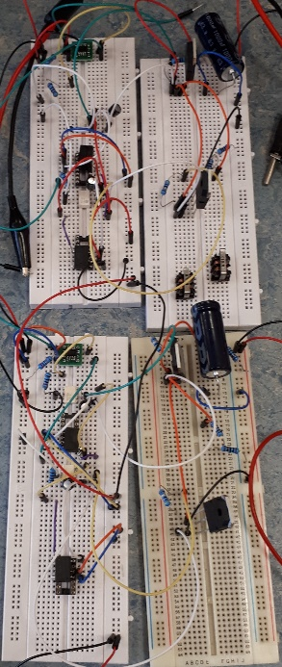
Figure 1 – Testing half-bridge submodules in laboratory
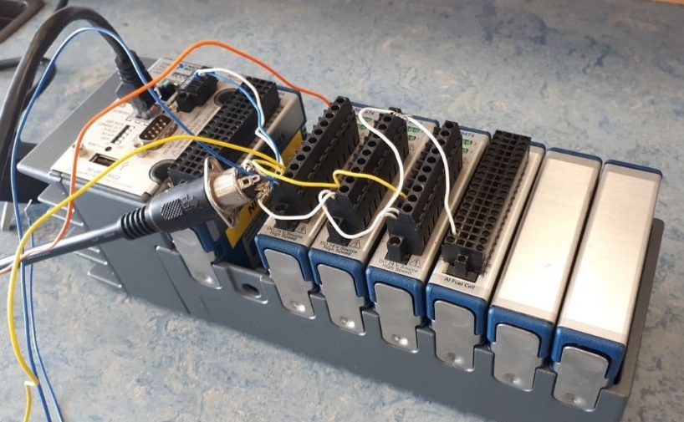
Figure 2 – National Instruments Compact RIO
- Update on publications
We have submitted a conference paper synopsis to the 23rd European Conference on Power Electronics and Applications (EPE 21). The conference is scheduled to be held in September 2021, in Ghent, Belgium. More information about this paper will be provided after its possible acceptance.
Another paper was presented in October on SIITME2020 Conference online, as a poster presentation, about converter topologies for MVDC traction transformer. The paper compares the conventional railway traction systems with new traction systems proposed and developed in the last decade that are also suitable for the Medium Voltage DC (MVDC) railway electrification concept presented in this project. Differences and requirements of the MVDC traction system were considered while investigating converter topologies for MVDC transformers (Power Electronic Traction Transformers – PETTs). Then, the paper is focused on presenting the most suitable DC-DC converters for this application, defining an example of optimal configuration and requirements of control, which in the future can be further developed for a novel MVDC railway electrification’s traction systems on-board.
We are also revising our review paper to submit it within the next months.

