S2R-OC-IPX-03-2018

Grant agreement n. 826238

Deliverable D1.3
WP summary report - the performance and characteristics of static converters for MVDC rail power supplies
Document details
Authors | Sina Sharifi, Pietro Tricoli
Due date | 30-04-2022
Actual delivery date | 28-06-2022
Lead contractor | University of Birmingham
Version | 1.0
Prepared by | University of Birmingham
Input from | -
Reviewed by | Technical University of Cluj-Napoca
Dissemination level | Public

Project contractual details
Project title | Flexible medium voltage DC electric railway systems
Project acronym | MVDC-ERS
Grant agreement no. | 828638
Project start date | 01.12.2018
Project end date | 30.04.2022
Duration | 41 months
Supplementary notes | The document type is public

Disclaimer:

* Please note that this deliverable is undergoing S2R JU review and acceptance processes. At this stage this deliverable reflects only the author’s view and the S2R JU is not responsible for any use that may be made of the information it contains.
Table of Contents
1 Introduction 3
2 Abbreviations and acronyms 4
3 Power converter of the medium voltage DC traction substations 5
4 Lab demonstrator of modular multilevel converter 6
4.1 Hardware configuration 6
4.2 Software design (Controller) 8
5 Experimental results 12
6 Technical key performance indicator KPI (c) - Validation process 17
7 Conclusion 18

Introduction
The present report constitutes deliverable D1.3, a document produced for Work Package 1 “Performance and characteristics of static converters for MVDC rail power supplies”.
The deliverable D1.3 describes the activities done in the Work Package 1 and the selection of modular multilevel converter with full-bridge submodules (MMC-FB) for the proposed medium voltage DC railway electrification system. Then it presents the developed small-scale prototype of MMC-FB, and investigates its performance. Finally, the document reviews the technical key performance indicator (KPI) “c”, “validation process”.

The deliverable has the following sections:
• Section 2, introduces abbreviations and acronyms used in this report;
• Section 3 briefly describes the activities done in the Work Package 1;
• Section 4 presents the developed lab demonstrator for the AC-DC power converter;
• Section 5 describes the experimental results;
• Section 6 reviews technical key performance indicator (KPI) c;
• Section 7 draws the conclusions.

Abbreviations and acronyms
Abbreviations and acronym | Definition
FFT | Fast Fourier transform
FPGA | Field-programmable gate array
IGBT | Insulated-gate bipolar transistor
MMC | Modular multilevel converter
MMC-FB | Modular multilevel converter with full-bridge submodules
MVDC | Medium voltage DC
PI | Proportional-Integral
PLL | Phase-locked loop
THD | Total harmonic distortion
TPS | Traction power substation

Power converter of the medium voltage DC traction substations
The high-power AC-DC converter topologies have been studied in the first stage of the project (refer to D1.1). Among these topologies, modular multilevel converter (MMC) was selected for the medium voltage DC (MVDC) traction power substations (TPSs), as it complies well with the proposed MVDC railway requirements. The ability of limiting DC short circuit currents is one of the essential requirements for the AC-DC power converter in the MVDC TPSs. Therefore, among various type of submodules for the MMC, full-bridge submodule was selected. Using full-bridges, the converter is able to produce negative arm voltages and hence, limit the DC short circuit currents.

The specifications of the proposed MVDC TPSs and the converter design have been reported in D1.2. In addition, a MMC with full-bridge submodules (MMC-FB) has been designed for the MVDC TPSs. The designed MMC has been simulated in Matlab/Simulink software. As important blocks, the controller and modulation stages have been designed and simulated. This development was started with MMC with half-bridge submodules and then was extended to MMC-FB. Then the simulation models were extended to MVDC railway networks to analyse the MMC-FB performance in different network configurations.
At the final stage of the project, a small-scale lab demonstrator of the MMC-FB was developed and tested. The implemented control and modulation scheme for the lab demonstrator are similar to those in the simulation models. The reactive power controller at the grid side, however, was not implemented and the reactive power consumption is only controlled at the output side of the autotransformer (converter side). The experimental setup is described in next section.

Lab demonstrator of modular multilevel converter

Hardware configuration

According to Fig. 1 (a), the prototype consists of 12 identical full-bridge submodules (two submodules per arm). As shown in Fig. 1 (b), at the AC side, the converter is connected to 415 V three-phase grid through an autotransformer. At the DC side, the converter provides 350 V DC and can be loaded up to 2 A.
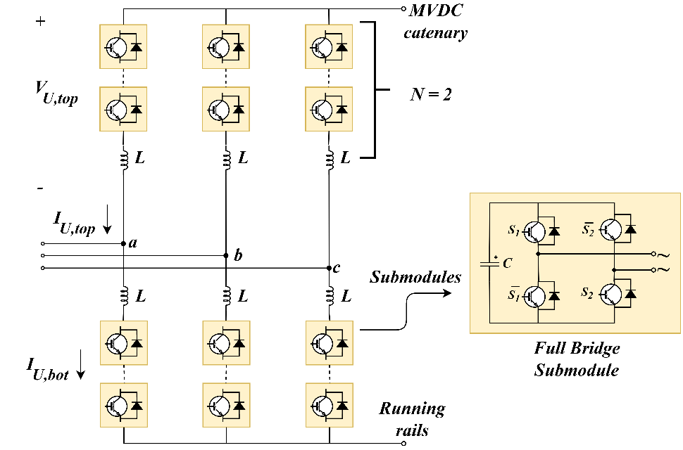
(a)
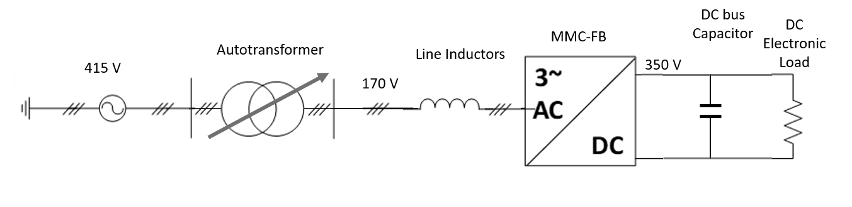
(b)
Fig. 1 - Schematic of: (a) MMC-FB, (b) the MMC-FB lab demonstrator.
Fig. 2 shows the whole experimental setup, located at University of Birmingham laboratory, and Table I presents its specifications. The electronic load simulates the trains’ load and it is connected to the DC bus of the prototype. The autotransformer is used to adapt the AC side voltage to the voltage suitable for the converter operation (170 V).
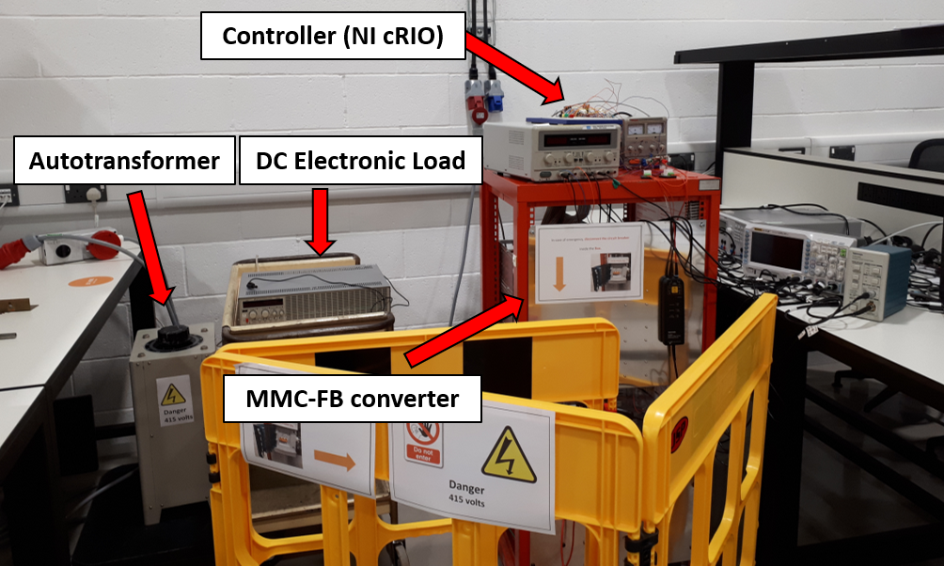 | 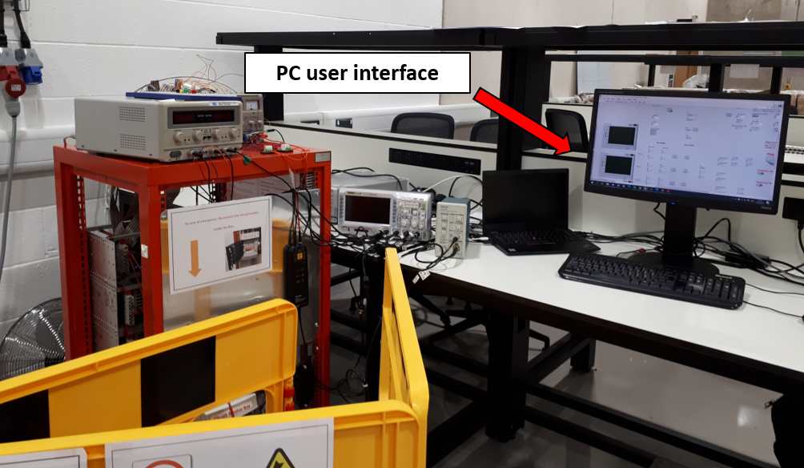
Fig. 2 - MMC-FB lab demonstrator.

Table 1: Parameters and specifications of the MMC-FB lab demonstrator
Parameter | Definition | Value
$$V_{DC,nom}$$ | Nominal voltage at DC side | 350 V
I_{DC,max} | Maximum DC current | 2 A
V_{ac,grid} | AC voltage (grid side) | 415 V
V_{ac,conv} | AC voltage (converter side) | 170 V
$$L_{arm}$$ | Total inductance of each arm | 650 µH
L_{line} | Line inductance | 16.5 mH
$$N$$ | Number of submodules in each arm | 2
$$V_{C,n}$$ | Capacitor nominal voltage in each submodule | 175 V
$$C_{sm}$$ | Capacitance of each submodule | 2200 µF
$$f_{s}$$ | Switching frequency of each submodule | 5 kHz
The MMC-FB components are mounted inside an enclosed rack and the line inductors are placed behind the rack. Fig. 3 shows the internal view of the converter, where the submodules, the arm current sensors, and the DC bus capacitor can be seen. The DC bus capacitor is used as a filter to mitigate DC voltage ripples.
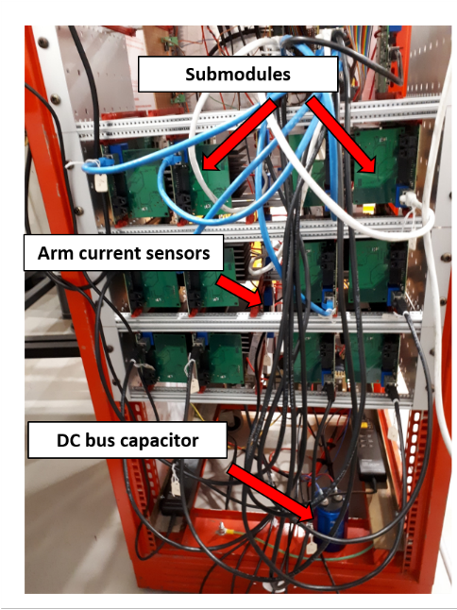
Fig. 3 - Internal view of the MMC-FB rack: The submodules, arm current sensors and the DC capacitor are demonstrated.
A detailed view of a full-bridge submodule is illustrated in Fig. 4. The main parts of the submodule are insulated-gate bipolar transistor (IGBT) module in full-bridge configuration, gate drivers, DC-DC converters for providing isolated supplies to the gate drivers, electrolytic capacitor, and voltage sensing circuitry.
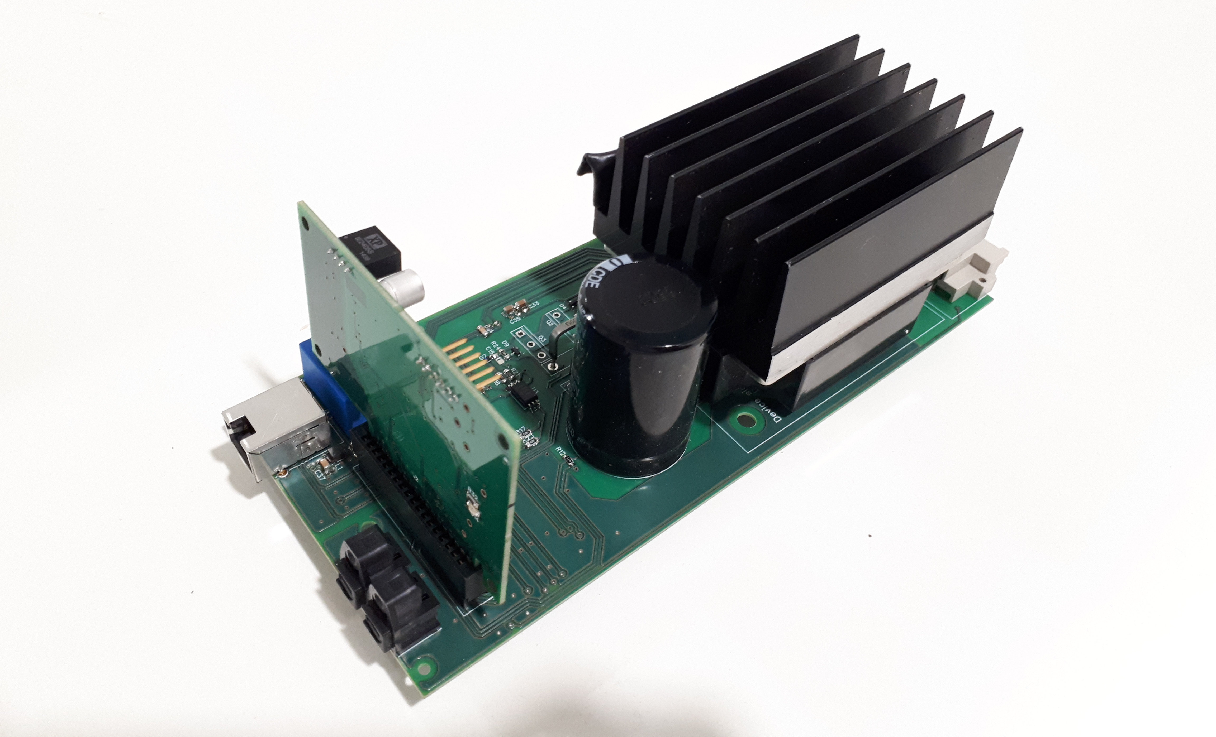
Fig. 4 - Full-bridge submodule.
National Instruments Compact RIO system has been selected for implementing the MMC control unit, and it is placed at the top of the converter rack (Fig. 5). On the controller, two analogue input and five digital output modules are used to implement the closed loop control. There is also one analogue output module which is used for monitoring the control signals.
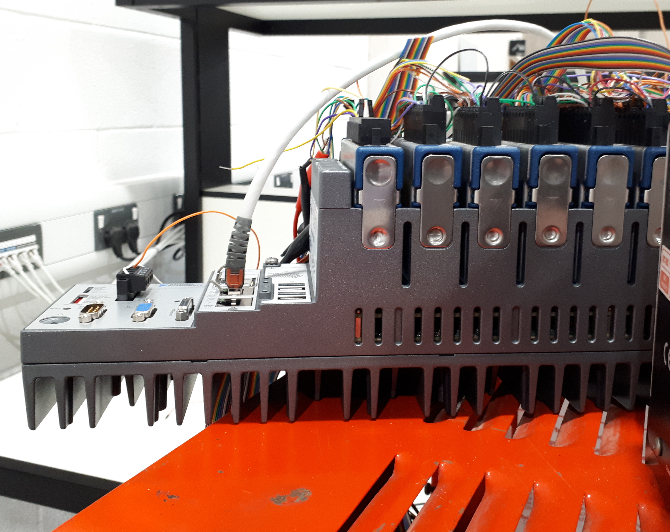
Fig. 5 - Controller of MMC-FB: National Instruments Compact RIO. The analogue input, analogue output, and digital output modules are mounted on the top.

Software design (Controller)

The Compact RIO system consists of a field-programmable gate array (FPGA) board and a real time target and is programmed by LabVIEW software. The real time target is used as an interface between the user and the FPGA target. The designed programme on the real time target enables the user to monitor a number of selected variables, and send commands and parameters to the FPGA programme.
Fig. 6 shows the designed real time programme, where the parameters for overcurrent and overvoltage protections, the value for deadtime, the commands to the contactors, and the parameters for the control loops can be set. It also shows the fault indicators, gate signal indicators, and the output value of the control loops.
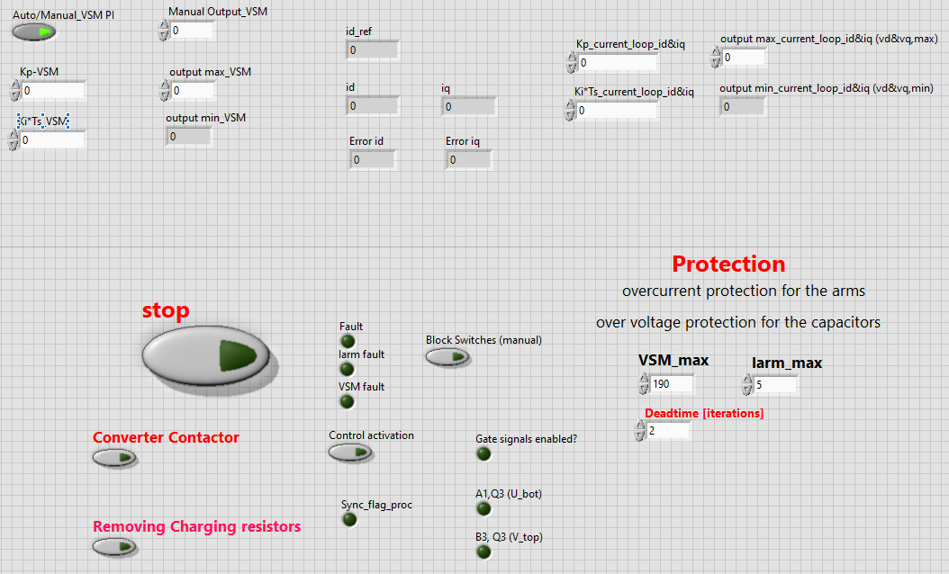
Fig. 6 - MMC-FB controller: the user interface designed on the real time target of NI Compact RIO.
The main part of the controller is implemented on the FPGA board. The developed FPGA programme mainly consists of four parts. Fig. 7 shows the first part, which creates the triangular carrier waveforms and transfers it to the third part of the code.
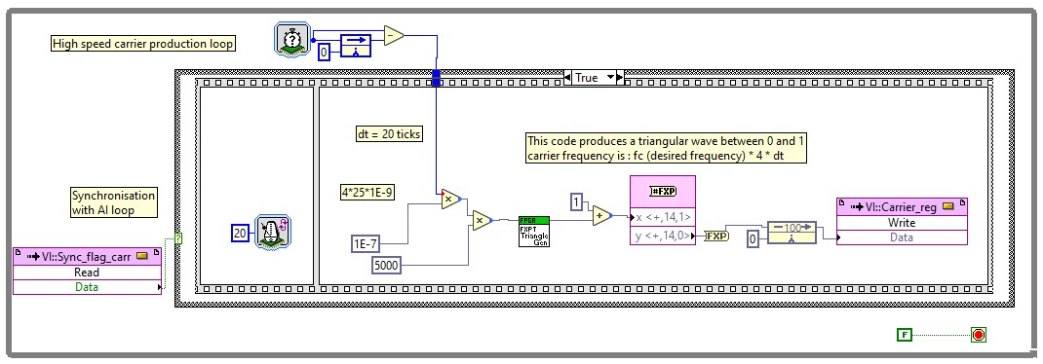
Fig. 7 - The developed FPGA programme: Producing 5 kHz triangular carriers.
The second part acquires analogue inputs (Fig. 8), and implements the software protections, i.e., overcurrent protection for the arms and overvoltage protection for the capacitors. Moreover, the phase-locked loop (PLL) block, Park transformation (ABC/DQ) and inverse Park transformation (DQ/ABC) are performed in this part of the programme, as shown in Fig. 9. It also implements the proportional-Integral (PI) controllers in the d-q frame, and sends the calculated AC references to the third part.
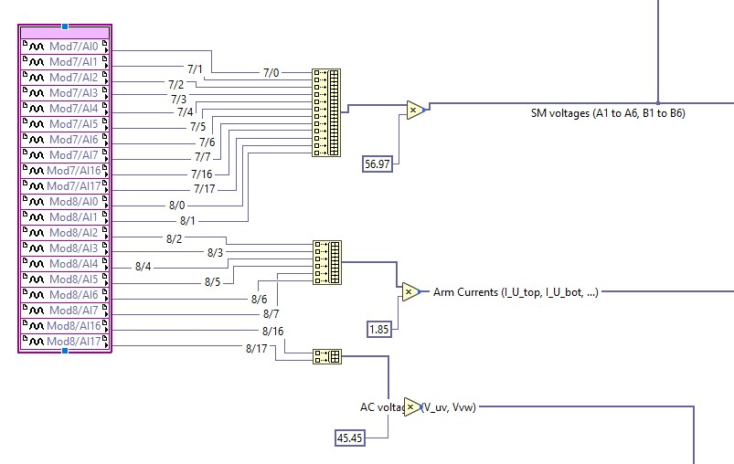
Fig. 8 - The developed FPGA programme: Acquiring analogue inputs and converting readings from the sensors to actual values.
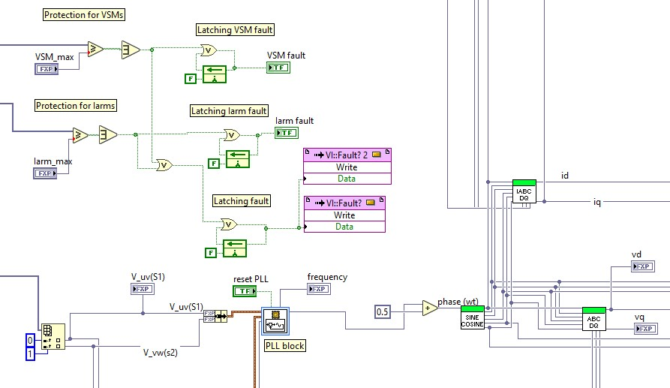
Fig. 9 - The developed FPGA programme: Software protection, PLL block, and d-q transformation blocks.
The third part is responsible for comparing the references with the carriers and evaluating the number of submodules that should be inserted in each time instant. As illustrated in Fig. 10, this part of the code also implements sorting algorithm for the submodule voltages in each arm, and creates gate signals for the four IGBTs in the full-bridge module. After applying deadtime on the gate signals, the gate signals are transferred to the digital output channels. The fault indicator produced by the first part is also monitored, and the IGBTs are blocked in the case of a fault.
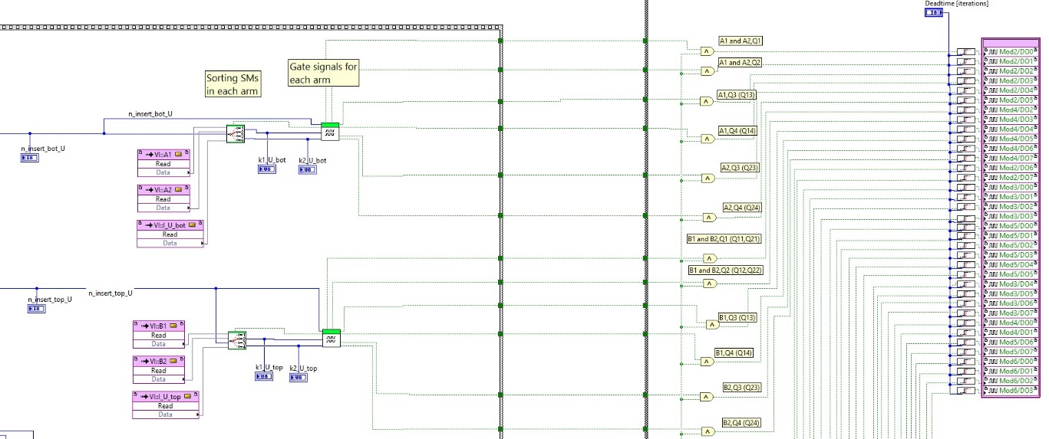
Fig. 10 - The developed FPGA programme: Sorting submodule voltages, producing gate signals - only one phase is shown -, applying deadtime and transferring gate signals to digital outputs.
The fourth part, shown in Fig. 11, transfers a number of selected signals to the analogue output channels. These signals are monitored on the scope during the tuning process of the controllers.
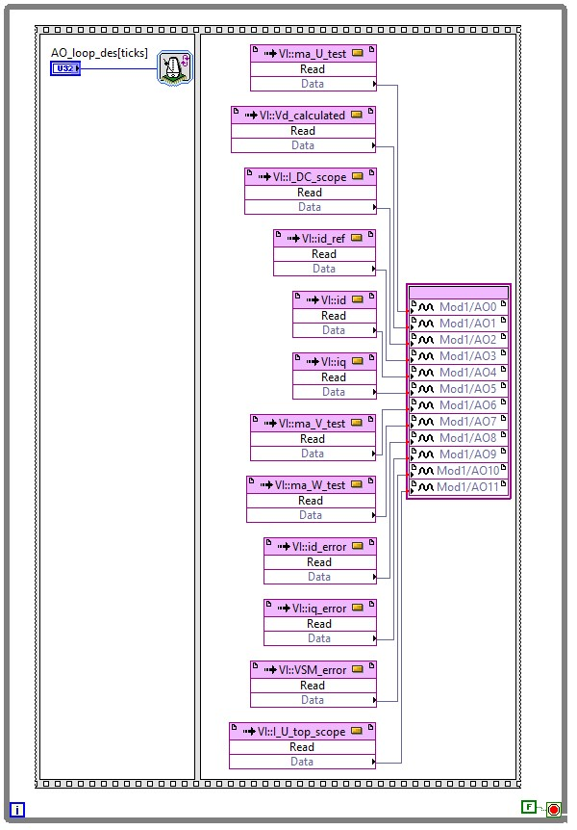
Fig. 11 - The developed FPGA programme: Monitoring selected signals using analogue output module.
.

Experimental results
The MMC-FB has been tested in various DC loads (I_{DC} = 0.5 A, 0.7 A, 1.4 A, and 2 A). In this section, the demonstrator performance is investigated when the converter is loaded by the DC electronic load in constant current mode (I_{DC} = 0.5 A). The set point for the submodules’ voltage is 175 V, which is equivalent to 350 V at the DC bus.
Fig 12 depicts the output DC voltage, which is quite smooth and has 6 V peak-peak ripple (1.74%). The actual average voltage is 344 V, as there are voltage drops on the elements between the submodules and the DC bus, and the controller only regulates the submodule voltages.
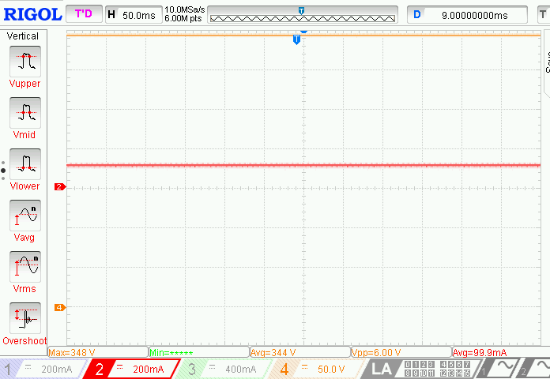
Fig. 12 - DC voltage (orange) and DC current (red – 1 A on scope = 5 A in reality).
Fig. 13 illustrates the AC phase currents at the output of the autotransformer (converter side - I_{U}, I_{V}, I_{W}) and the voltage of phase U with respect to neutral (V_{UN}). It can be seen that the converter draws balanced currents, and the currents are nearly sinusoidal. In addition, current of phase (I_{U}) is in phase with V_{UN} (Fig. 14), showing that the current control loop works properly and keeps the reactive power consumption in output side of the autotransformer to nearly zero.
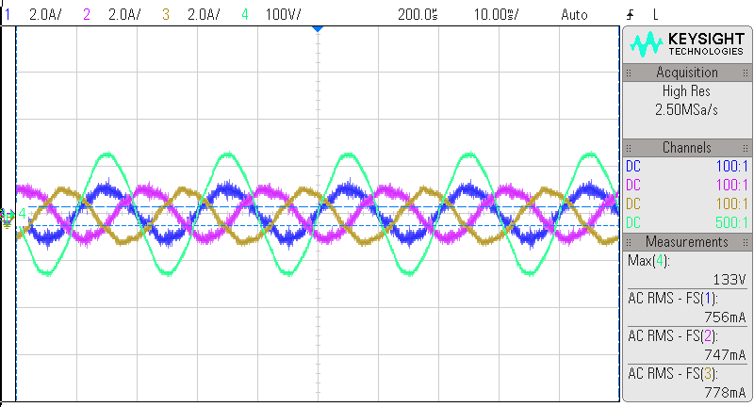
Fig. 13 - A phase voltage and three phase currents at DC load of 0.5 A (CH1: I_{U}, CH2: I_{V}, CH3: I_{W}, CH4: V_{UN}).

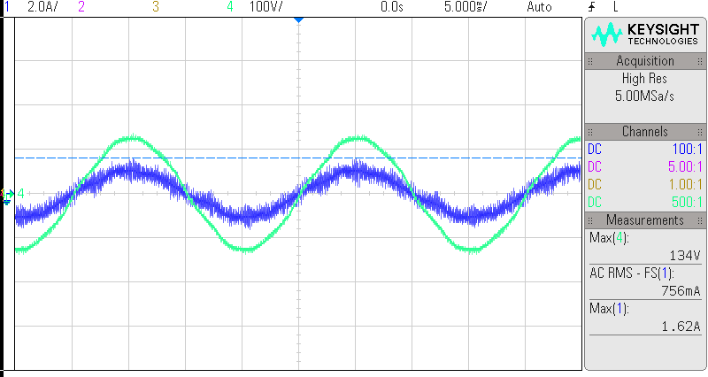
Fig. 14 - Zero reactive power consumption in output side of the autotransformer (CH1: I_{U} and CH2: V_{UN}.
The voltage of top arm in phase U (V_{U,top}) is presented in Fig. 15, showing that the arm voltage has three levels as expected, and the average of the arm voltage is approximately equal to half of the DC bus voltage. The voltage of top and bottom arm of phase U are demonstrated in Fig. 16, which are 180 degrees out of phase.
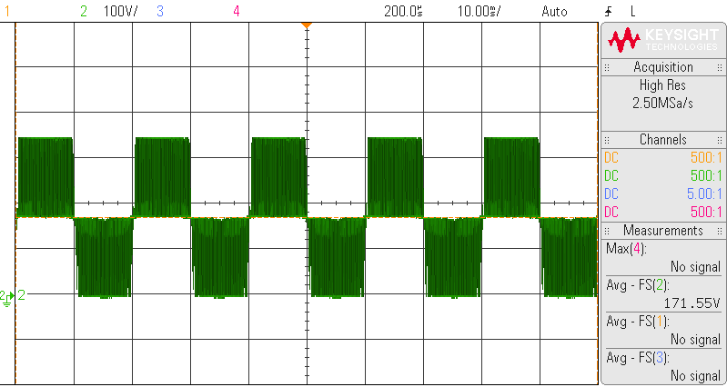
Fig. 15 - The voltage of top arm in phase U (V_{U,top}).
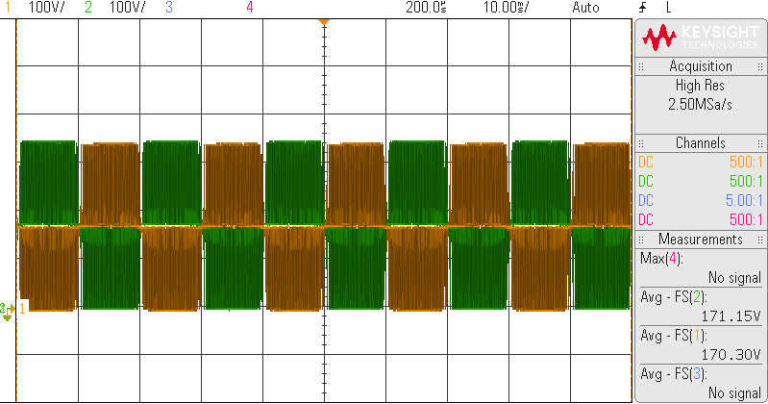
Fig. 16 - The voltage of top and bottom arm in phase U (CH2: V_{U,top} , CH1: V_{U,bot} ).
Fig. 17 depicts the arm current of the top arm in phase U (I_{U,top}) and its harmonic spectrum, calculated by Fast Fourier transform (FFT). The arm current mainly contains the fundamental harmonic (50 Hz), and 2nd harmonic (100 Hz). There are also some harmonic contents around the switching frequency (5 kHz), but their amplitude is negligible. This is also the case for the phase current as shown in Fig. 18.
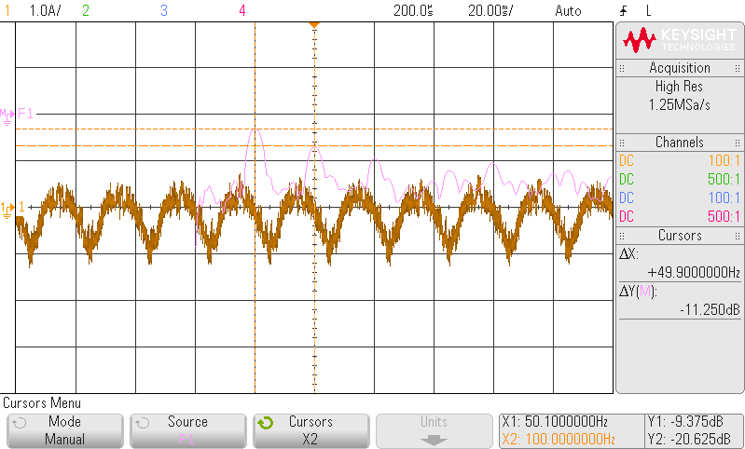
(a)
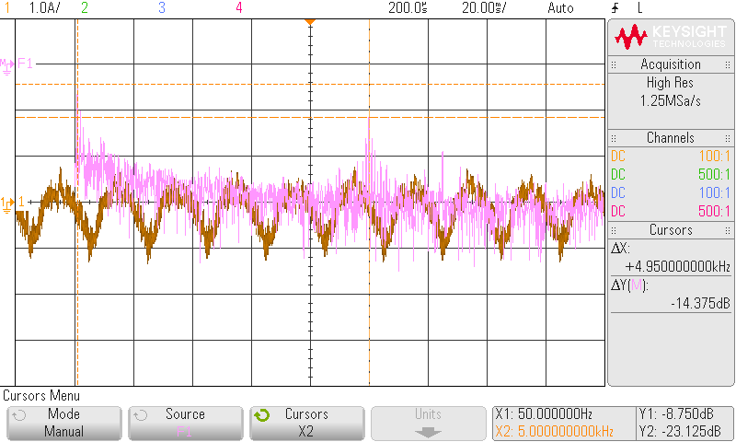
(b)
Fig. 17- arm current of the top arm in phase U (I_{U,top}) and its harmonic spectrum: (a) FFT span = 100 Hz; (b) FFT span = 10 kHz.
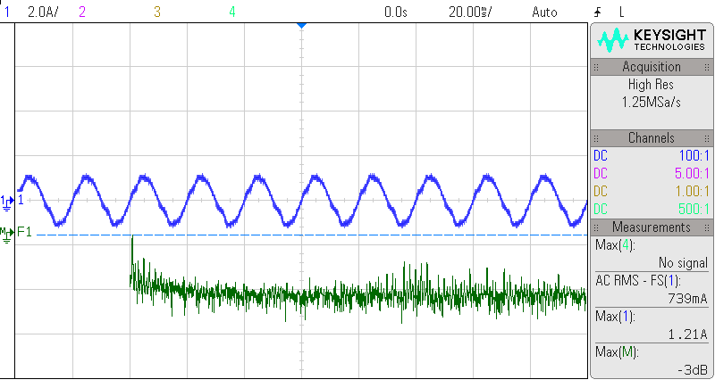
Fig. 18 - Current of phase U (I_{U}) and its harmonic spectrum: FFT span = 10 kHz.

As depicted in Fig. 19, the phase current mainly contains the fundamental component (50 Hz). It also contains 2nd, 3rd, 5th, 7th and 9th harmonics. Based on the amplitudes of the harmonic components, the total harmonic distortion (THD) for the phase current is 7.55 %. Considering that the converter has only two submodules per arm, the amount of THD is acceptable. By increasing the number of submodules and thus, the produced voltage levels, the THD of the phase current decreases.

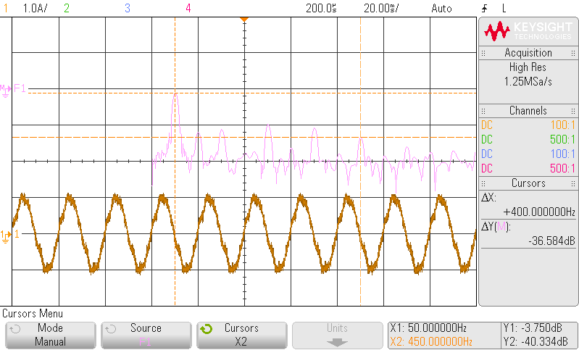

Fig. 19 - Current of phase U (I_{U}) and its harmonic spectrum: FFT span = 700 Hz.

Technical key performance indicator KPI (c) - Validation process
c1) Difference of the current drawn by the converter between experiment and simulation:
As an example, the simulation model and the lab demonstrator are compared when a DC load of 0.5 A is applied to the converter. The peak and RMS value for the phase current of phase U at the converter side in the simulation are 0.6 A and 1 A, respectively. In the lab demonstrator, these values are 0.7 A and 1.2 A. Therefore, the difference between the RMS values is 0.1 A, and the difference between peak values is 0.2 A.
At the output side of the autotransformer, the Fourier analysis of the phase current of the lab demonstrator illustrates that there are negligible harmonic contents around the switching frequency (5 kHz).
Considering the DC bus voltage, the DC voltage provided by the lab demonstrator has the average of 344 V with peak to peak ripple of 6 V (1.74%). In the simulation model, the average of DC voltage and its peak to peak ripple are 350 V and 5 V (1.43%), respectively.
The differences are due to the approximations made in the simulation model and the difference between the entered parameters in the simulation and the actual values in reality.
c2) time response of the control loop:
MMC with full-bridge submodules has been selected to be used in the TPSs and the size of its passive elements for the simulations and the lab demonstrator have been determined. The simulation cases stated in D1.2 show that the DC short circuit current controller can limit the fault current within 370 µs and after that, the mean value for the current is less than $I_{DC,max}$ = 120% of nominal DC current. Therefore, the KPI objective has been achieved in the simulation model. The DC short circuit current controller has not been tested on the lab demonstrator due to lack of time.

Conclusion
This deliverable briefly presents the activities done in Work Package 1. The document focuses on the developed lab demonstrator for the MMC-FB, describing the system schematic, the hardware arrangement, and the selected controller. Then the deliverable presents the experimental results and analyses the converter performance. The results show that the developed control system is able to properly synchronise the produced arm voltages with the AC grid. It also regulates the capacitor voltages, while the converter draws balanced and high-quality AC currents from the grid. Therefore, the converter can properly feed the DC side load. At the end, the document reviews the technical key performance indicator (KPI) (c), “Validation process”.

